VADIM Mercer Isl. Parcel #1438700150 - RATING FIGURES
Figure 1. Cowardin Plant Class
Figure 2. Hydroperiod
Figure 3. Ponded Depressions

Figure 4. Unit vs. Stream Width
Figure 5. 150-Ft. Buffer & Outlet
Figure 6. contributing Basin

Figure 7. 1 Km Poly with Accessible & Undisturbed

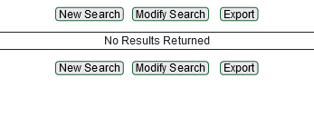
Figure 8. TMDLs for watershed

